Pepin Trailblazers
September 3, 2023
NBHA Sanctioned WI 03 & MN 02/03
Arena located 2 miles east of Pepin on Hwy 35
Sanctioned IBRA, NBHA & PEWC

Sunday September 3
Exhibitions 8:00-9:00
Open Arena 9:00-9:15
1st class to start at 9:30 am

1. Open 2D Pole Bending $10.00 $25.00 added
2. Pee Wee Barrels (10 & under ) $5.00
Pee Wee Barrel participants may not be entered in any other barrel class
3. Open 4D NBHA Barrel $20.00 $100.00 added
4. Youth NBHA Barrels $10.00 $25.00 added
5. Senior NBHA Barrels $10.00 $25.00 added
6. IBRA 4D Barrels ½split $20.00 $100.00 Added
7. Master IBRA $10.00
8. Adult IBRA $10.00
9. Youth IBRA $10.00

Timer/Arena Charge $10.00 per rider
Carry overs allowed, no office fee for pee wee
Any horse/rider changes/carry-overs requested after entered is a $5 fee per request

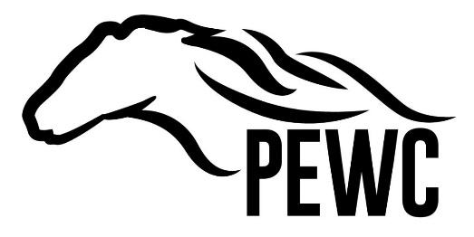
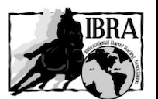
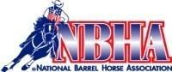

Current coggins required-need to bring a copy
Water on grounds No Refunds
Must sign waiver
Carryovers allowed
$3.00 of your entry fee for NBHA will go to NBHA. $2.00 of the IBRA entry fee goes to IBRA
Pole classes: 2D is 1 second off fastest time.
75% payback. Added money paid at 100% Payback based on # of entries . NBHA rules and dress code enforced.
Please bring your lawn chairs.

