MENOMONIE SADDLE CLUB NBHA/IBRA OPEN
​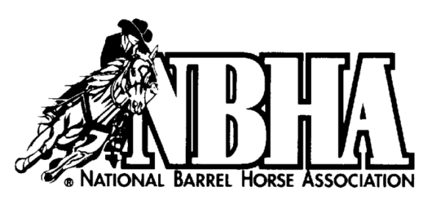 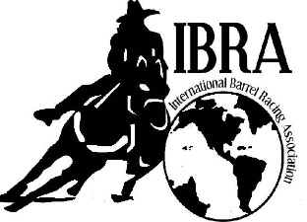
JUNE 10 & 11 2023 $ ADDED MONEY
​ NBHA/IBRA BARRELS AND POLES JACKPOT DUNN COUNTY FAIRGROUNDS/REC PARK
_____________________________________________________________________________________
June 10: Exhibitions - 8:30-10:30 Open Arena - 10:30-10:45 Show - 11:00
June 11: Exhibitions - 7:00-8:30 Open Arena - 830 - 8:45 Show - 9:00
____________________________________________________________________________________
Exhibitions $ 5
Open 2D Pole Bending (2 second split) $10
Pee Wee Barrels
NBHA Open 4D Barrels $20
NBHA Youth Barrels $15
NBHA Senior Barrels $15
IBRA Open 4D Barrels (1/2 second split) (May carry over from NBHA) $25
IBRA Adult Class (Ages 19-30) (May carry over from NBHA or IBRA Open) $15
IBRA Youth Class (May carry over from NBHA or IBRA Open) $15
IBRA Masters (May carry over from NBHA or IBRA Open) $15
Novice Horse 2D Barrels (Full second split – May carry over from Open) $15
Horses 5 and under in first year of competition or LTE under $500.
Exhibitions must be under 60 seconds. Riders may circle each barrel once.
Office Fee $6/horse per day NEGATIVE COGGINS REQUIRED
STALLS; Box stall reservations (715) 556 0007. Stalls are $40/weekend with $20 refund if stall is cleaned.
Provide own shavings. Tie-Outs allowed. (No large pens) CAMPING ALLOWED (no electric)
LUNCH STAND (Including Sunday Breakfast)
Info: (715-556-0007) Email: kathy_mikesell@yahoo.com

