 NBHA- IBRA 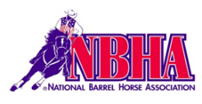

Barrels & Poles Jackpot

MONDOVI, WI

Sept. 2, 2023

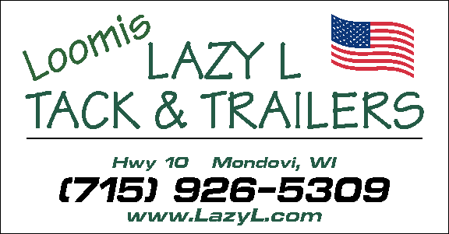 NBHA WI-03

Exhibition Barrels

Exhibition Poles

1. Open 2-D Poles $20.00

2. 13 and Under Poles $10.00

3. Pee Wee Barrels(no office fee) $ 5.00

4. 13 and under Barrels $10.00

5. Open Barrels NBHA $25.00

6. Youth Barrels NBHA $20.00

7. Senior Barrels NBHA $20.00

8. Open 4-D Barrels IBRA $25.00 $$Added $$

9. Junior Barrels IBRA (18 & under) $20.00

10. Adult Barrels IBRA(19-39) $20.00

11. Masters BarrelsIBRA (40 & over)$20.00

Carry overs allowed.

Exhibition starts at 8am 1st class 10:30

Don’t forget:: Horse Pull Sunday Sept. 4 11:00 am

Current ’23 Neg Coggins required-original and a copy. No Refunds. Lunch stand on grounds.

Horses that pose a danger to others may be excused. Stalls, Pens, & Camping Available.

Information: Lazy L or Krissy @ 715-926-5309

Lazy L Tack & Trailers, H&L Cattle or Loomis Family is Not responsible for accidents of any kind

No Emergency Medical Technicians on grounds.

ALL DOGS MUST BE KEPT ON A LEASH AND AT YOUR TRAILER.

Absolutely no dogs near crows nest & arena area.